Name : Pragati Ghorpade
PRN : 202501050030

Practical 3
1)
Program :
import numpy as np
rows, cols = map(int, input().split())
elements = []
for _ in range(rows) :
elements.extend(map(int, input().split()))
array = np.array(elements).reshape(rows, cols)
print(array)
print(array.ndim)
print(array.shape)
print(array.size)
Output :
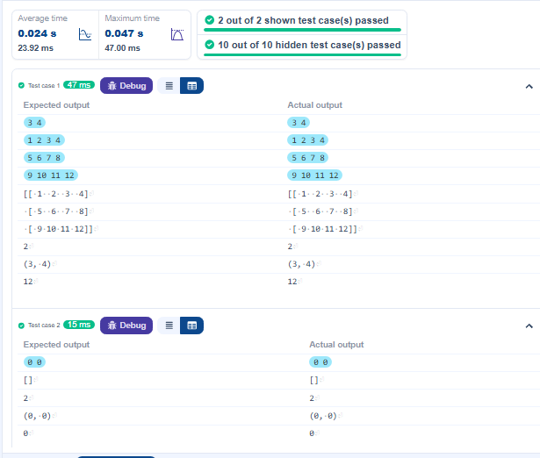

2)
Program :
import numpy as np
# Input matrices
print("Enter Matrix A:")
matrix_a = np.array([list(map(int, input().split())) for i in range(3)])
print("Enter Matrix B:")
matrix_b = np.array([list(map(int, input().split())) for i in range(3)])
# Addition
addition_result = matrix_a + matrix_b
print("Addition (A + B):")
print(addition_result)
# Subtraction
subtraction_result = matrix_a - matrix_b
print("Subtraction (A - B):")
print(subtraction_result)
# Multiplication (element-wise)
elementwise_multiplication_result = matrix_a * matrix_b
print("Element-wise Multiplication (A * B):")
print(elementwise_multiplication_result)
# Matrix multiplication (dot product)
matrix_multiplication_result = np.dot(matrix_a, matrix_b)
print("A dot B:")
print(matrix_multiplication_result)
# Transpose
transpose_a = matrix_a.T
print("Transpose of A:")
print(transpose_a)
Output :
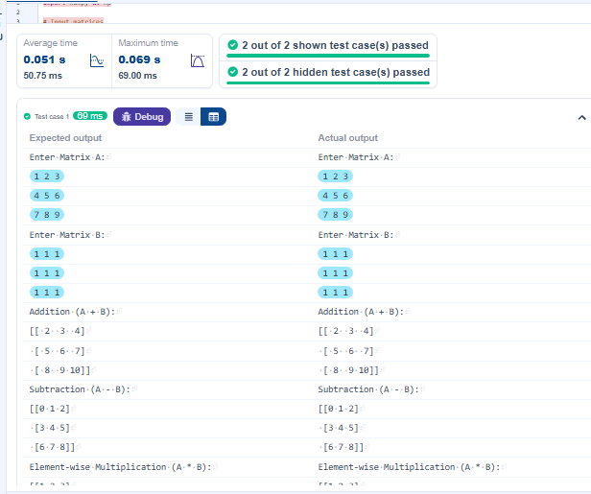

3)
Program :
import numpy as np
# Input matrices
print("Enter Array1:")
arr1 = np.array([list(map(int, input().split())) for i in range(3)])
print("Enter Array2:")
arr2 = np.array([list(map(int, input().split())) for i in range(3)])
# Perform horizontal stacking (hstack)
a = np.hstack((arr1,arr2))
print("Horizontal Stack:")
print(a)
# Perform vertical stacking (vstack)
b = np.vstack((arr1,arr2))
print("Vertical Stack:")
print(b)
Output :
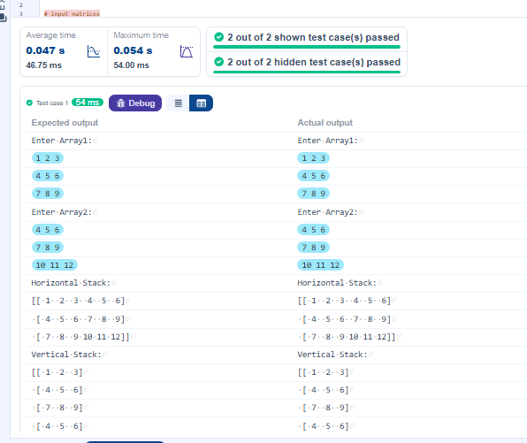

4)
Program :
import numpy as np
# Take user input for the start, stop, and step of the sequence
start = int(input())
stop = int(input())
step = int(input())
# Generate the sequence using np.arange()
a= np.arange(start,stop, step)
print(a)
# Print the generated sequence

Output :
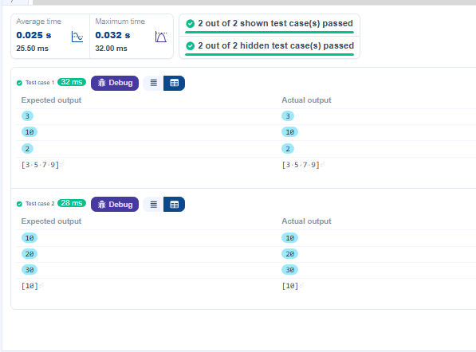

5)
Program :
import numpy as np

def array_operations(A, B):

# Convert A and B to NumPy arrays
A = np.array(A)
B = np.array(B)

# Arithmetic Operations
sum_result = A + B
diff_result = A - B
prod_result = A * B

# Statistical Operations
mean_A = np.mean(A)
median_A = np.median(A)
std_dev_A = np.std(A)

# Bitwise Operations
and_result = A & B
or_result = A | B
xor_result = A ^ B

# Output results with one space between each element
print("Element-wise Sum:", ' '.join(map(str, sum_result)))
print("Element-wise Difference:", ' '.join(map(str, diff_result)))
print("Element-wise Product:", ' '.join(map(str, prod_result)))

print(f"Mean of A: {mean_A}")
print(f"Median of A: {median_A}")
print(f"Standard Deviation of A: {std_dev_A}")

print("Bitwise AND:", ' '.join(map(str, and_result)))
print("Bitwise OR:", ' '.join(map(str, or_result)))
print("Bitwise XOR:", ' '.join(map(str, xor_result)))

A = list(map(int, input().split())) # Elements of array A
B = list(map(int, input().split())) # Elements of array B
array_operations(A, B)

Output :
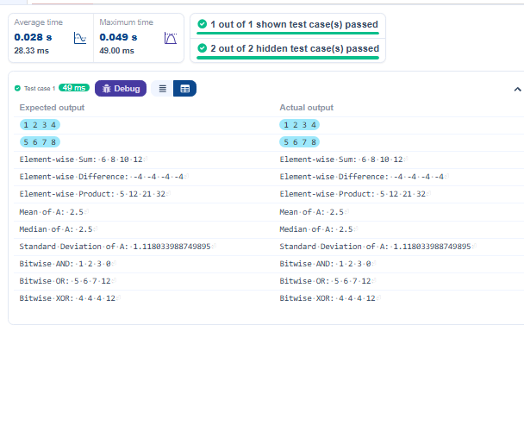
6)
Program :
import numpy as np

inputlist = list(map(int,input().split(" ")))

# Original array
original_array = np.array(inputlist)

# Create a view
view_array = original_array.view()

# Create a copy
copy_array = original_array.copy()

# Modify the view
view_array[0] = 99
print("Original array after modifying view:", original_array)
print("View array:", view_array)

# Modify the copy
copy_array[1] = 88
print("Original array after modifying copy:", original_array)
print("Copy array:", copy_array)
Output :
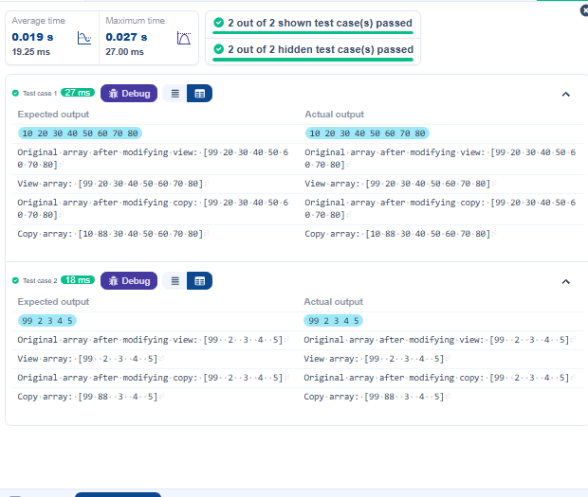

7)
Program :
import numpy as np

# Input array from the user
array1 = np.array(list(map(int, input().split())))

# Searching
search_value = int(input("Value to search: "))
count_value = int(input("Value to count: "))
broadcast_value = int(input("Value to add: "))

# Find indices where value matches in array1
a=np.where(array1==search_value)[0]
print(a)
# Count occurrences in array1
b=np.count_nonzero(array1==count_value)
print(b)
# Broadcasting addition
c=array1 + broadcast_value
print(c)
# Sort the first array
d=np.sort(array1)
print(d)

Output :
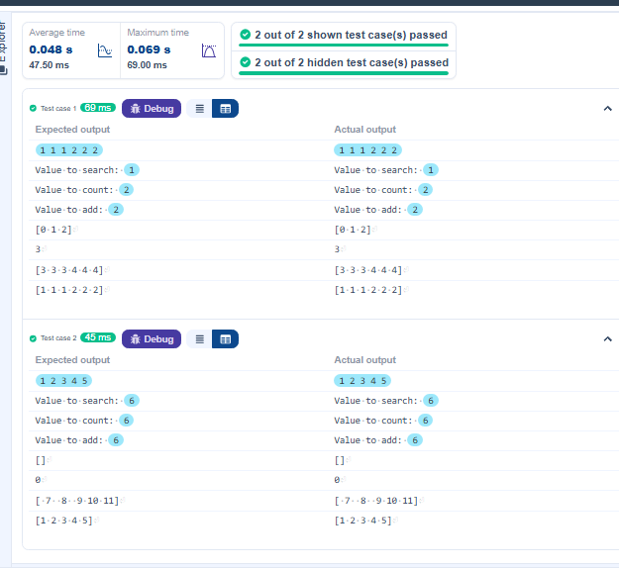

8)
Program :
import numpy as np
a = np.loadtxt("Sample.csv", delimiter=',', skiprows=1)
print("All student Details:\n",a)
print("Total Students:", len(a))
print("All Student Roll Nos", a[:,0] )
print("Subject 1 Marks", a[:,1])
print("Min marks in Subject 2", a[:,2].min() )
print("Max marks in Subject 3", a[:,3].max() )
a1 = np.delete(a,0,1)
print("All subject marks:", a1 )
print("Total Marks", a[:,1]+a[:,2]+a[:,3] )
a2 = np.array(a[:,1]+a[:,2]+a[:,3])
A =np.around(a2/3,1)
print(A)
s1 = (a[:,1]).mean()
s2 = (a[:,2]).mean()
s3 = (a[:,3]).mean()
A1 = np.array((s1,s2,s3))
print("Average Marks of each subject", A1 )
A2 = np.array((s1,s2))
print("Average Marks of S1 and S2", A2 )
A3 = np.array((s1,s3))
print("Average Marks of S1 and S3", A3 )
i = (a[:,3]).argmax()
r = a[i][0]
print("Roll no who got maximum marks in Subject 3", r )
I = (a[:,2]).argmin()
R = a[I][0]
print("Roll no who got minimum marks in Subject 2", R )
r1 = (a[(a[:,2])== 24 ,0]).reshape(-1,1)
print("Roll no who got 24 marks in Subject 2", r1 )
count = np.argwhere(a[:,1]<40)
c = len(count)
print("Count of students who got marks in Subject 1 < 40", c )
count1 = np.argwhere(a[:,2]>90)
c1 = len(count1)
print("Count of students who got marks in Subject 2 > 90:", c1 )
Count = [len(np.argwhere(a[:,1]>=90)),len(np.argwhere(a[:,2]>=90)),len(np.argwhere(a[:,3]>=90))]
Count = np.array(Count)
print("Count of students in each subject who got marks >= 90:", Count )
print("Roll no:", a[:,0] )
count0 = []
for i in range(len(a[:,0])):
val = 0
if a[i][1]>=90:
val = val + 1
elif a[i][2]>=90:
val = val + 1
elif a[i][3]>=90:
val = val + 1
count0.append(val)
count0 = np.array(count0)
print("Count of subjects in which student got marks >= 90:", count0 )
asc = np.sort(a[:,1])
print(asc)
print(a[a[:,1]>=50])
print(a[a[:,1]<=90])
print(np.where(a[:,1]==79))

Output :
